Case 1-Eur-Italy-Piacenza Province-Hand Axe-Limestone-Acheulean-1 mya
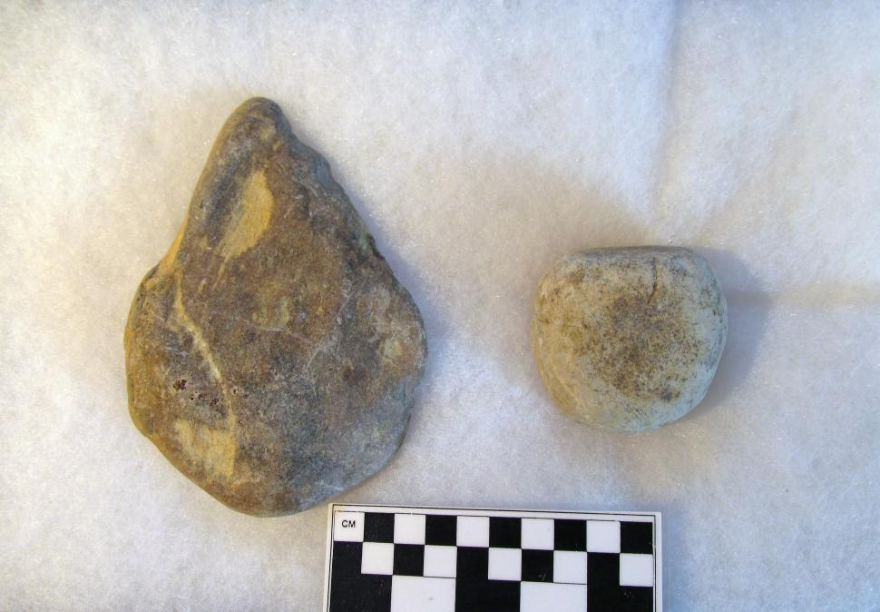
Left: Late Acheulean hand axe, Homo Erectus. Right: Accompanying abrader, quartzite. Surface collected by Susan Murcott, Province of Piacenza, Italy.
Case No.: 1
Accession Number:
Formal Label: Eur-Italy-Piacenza-Hand Axe and Abrader-Limestone and Quartzite- Acheulean-1 mya
Display Description:
Since raw material constrains the shape of bifaces (Jones 1981), this particular limestone specimen reflects the application of a basal grinder which was used to shape the specimen into its traditional "tear drop" shape. This specimen was surface collected by Susan Murcott on a ridge overlooking a valley in the Province of Piacenza, north of Monte Poggiolo.
Murcott also surface collected an abrader near the hand axe that could have been used to shape the limestone of the hand axe: abrading is obvious in the upper left quadrant and the base of the specimen, while flaking is obvious in the upper right quadrant. Therefore, the two specimens, the hand axe and the abrader, may have been part of an ancient Homo Erectus hunter's toolkit as he watched the game in the valley below, while he finished shaping his weapon.

LC Classification:
Date or Time Horizon: 1 mya
Geographical Area: Province of Piacenza, Italy, north of Monte Poggiolo, the site of Acheulean lithics.
Map:
GPS Coordinates:
Cultural Affiliation: Acheulean, Homo Erectus
Medium: limestone and quartzite
Dimensions: hand axe, W 9.3 cm, L 12.8 cm, T 2.7 cm
Weight:
Provenance: surface collected by Susan E. Murcott, 2015
Condition: original
Discussion:
John Frere from Hoxne in Suffolk, England, is generally credited as being the first to suggest a very ancient date for Acheulean hand-axes. In 1797, he sent two examples to the Royal Academy in London. The type site for the Acheulean techno-complex is Saint-Acheul, a suburb of Amiens, in Picardy, northern France, where artifacts were found in 1859.

Acheulean hand axes have been found over much of Africa, Europe, and Asia; from the British Isles to southern Africa, and from the Iberian Peninsula (Spain/Portugal) to China. The Acheulean hand axe industry is significant because it marks a conceptual shift in the making of stone tools, which conceptualized a cognitive development in Homo Erectus of perceiving a mental template within a stone. This required planning and purpose in the mind of the knapper to remove many flakes to form a symmetrical tear-drop shape that was emulated and imitated over great distances for over 1 million years. It is suggested that other intellectual structures may have accompanied this development such as communication in these early hominins. While there is a basic paradigm in the shape of the Acheulean had axe, at least three different Acheulean modal shapes were developed based on broad geographical distributions: Africa, Europe and Western Asia (Wynn and Tierson. 1990).
The Core-flake Tool Industry of this Acheulean hand axe is possibly derivative of the African modal shape and which is associated with Monte Poggiolo in northern Italy.
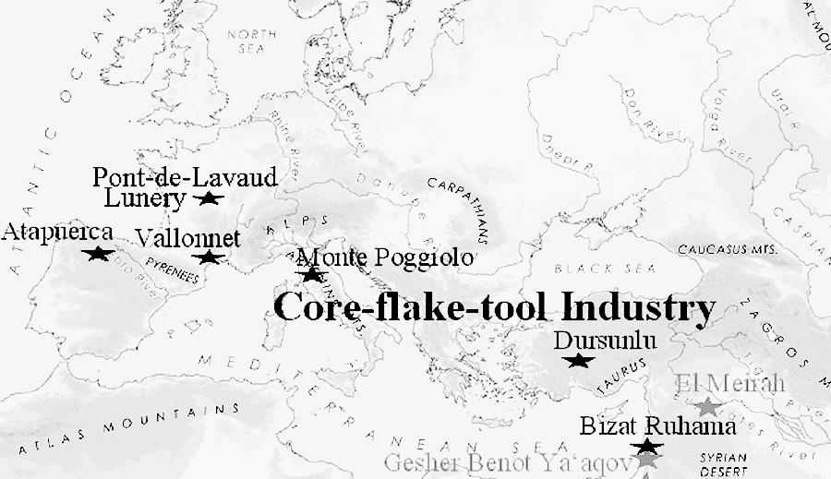
Fig. 2. Map of major Acheulean Core-flake Tool sites 1 mya. After Doronichev 2010:333, fig. 6.

This shape reflects a late Acheulean tradition distinct from the Mousterian Levallois flint tool industry associated primarily with Homo neanderthalensis and dating to the Middle Paleolithic
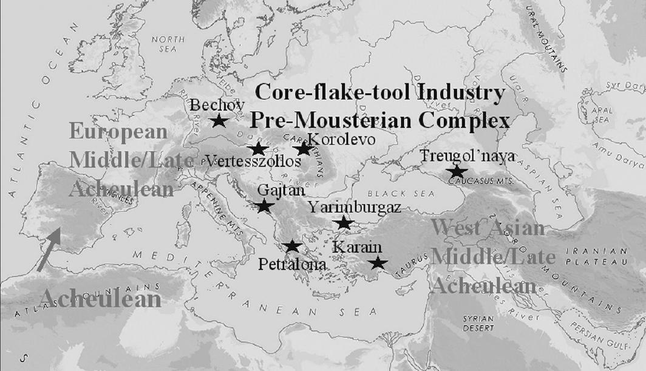
Fig. 3. Diffusion of the Acheulean techno-complex into south-western Europe showing its separation from the pre-Mousterian Complex of Homo Neanderthalensis from the Black Sea west, 0.7-0.3 Ma. After Doronichev 2010:334, fig. 7.

References:
Doronichev, V. and Liubov Golovanova. 2010. Beyond the Acheulean: a view on the Lower Paleolithic occupation of western Eurasia, Quaternary International, 327-344.
Jones, P. Effects of raw materials on biface manufacture, Science 204: 835-836.
Wynn, T. and F. Tierson. 1990. Regional comparison of the shapes of later Acheulean handaxes, American Anthropologist, 92: 73-84.

